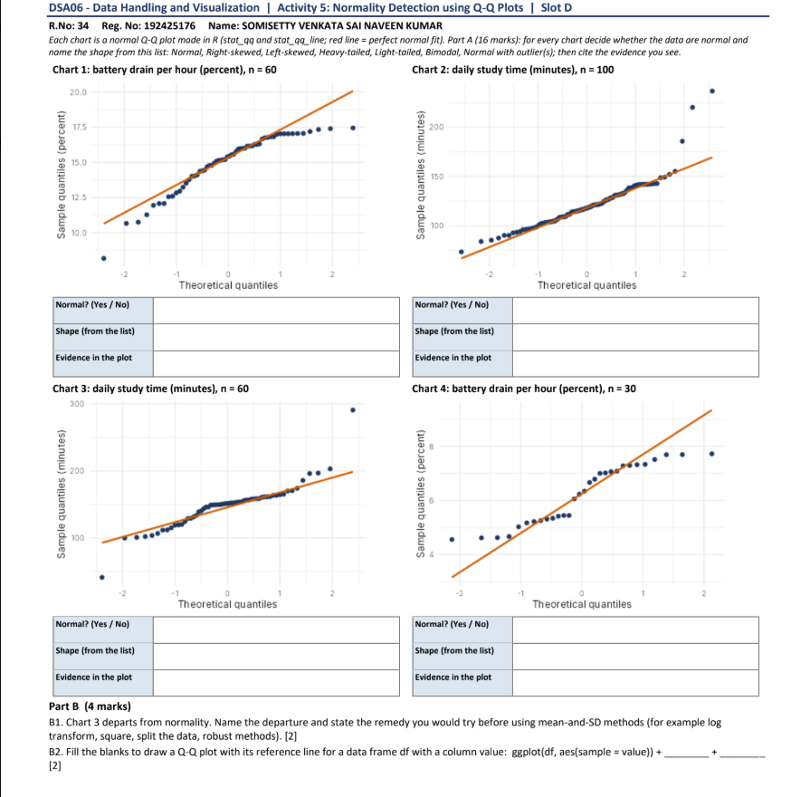

Part A (16 marks)
Chart 1: Battery drain per hour (percent), n = 60
Normal? (Yes / No) | No
Shape (from the list) | Left-skewed
Evidence in the plot | The points bend below the red line at both ends (concave-down curve). The lowest points, near 8 and 10.5, sit well below the line, so the lower tail is long and stretched. The upper points flatten out at about 17.5, below the line, so the upper tail is cut short. The middle of the data follows the line closely.
Chart 2: Daily study time (minutes), n = 100
Normal? (Yes / No) | No
Shape (from the list) | Right-skewed
Evidence in the plot | The middle follows the line, but the upper end curves sharply above it (convex curve). The largest points, near 185, 220 and 238, lie far above the line, so the upper tail is long and stretched. The lowest points sit slightly above the line, so the lower tail is short.
Chart 3: Daily study time (minutes), n = 60
Normal? (Yes / No) | No
Shape (from the list) | Heavy-tailed
Evidence in the plot | The plot has an S-shape: the central points sit flat and tight around 150, while both ends move away from the line, with the left end below it and the right end above it. Two extreme points, near 35 at the bottom and near 290 at the top, lie far from the line on opposite sides. Extreme values occur at both ends more often than a normal distribution would give.
Chart 4: Battery drain per hour (percent), n = 30
Normal? (Yes / No) | No
Shape (from the list) | Light-tailed
Evidence in the plot | The ends flatten out in an S-shape. The lowest points are stuck at about 4.5, above the line, and the highest points are stuck at about 7.7, below the line. Both tails are shorter than a normal distribution would give, so the values are bunched between about 4.5 and 7.7 with no extreme values.
Part B (4 marks)
B1. Chart 3 departs from normality. Name the departure and state the remedy you would try before using mean-and-SD methods. [2]
Departure: Chart 3 is heavy-tailed. The centre follows the line, but both tails move away from it, and there are two extreme outliers (about 35 and 290 minutes).
Remedy: Use robust methods before relying on the mean and SD. I would summarise the data with the median and IQR (or a trimmed mean) and first check the two extreme points for entry errors. A log transform is not suitable here, because it corrects one-sided (right) skew, whereas this data has heavy tails on both sides.
B2. Fill the blanks to draw a Q-Q plot with its reference line for a data frame df with a column value. [2]
ggplot(df, aes(sample = value)) + stat_qq() + stat_qq_line()
Blank 1: stat_qq() (draws the sample-vs-theoretical quantile points)
Blank 2: stat_qq_line() (draws the reference line)

